1. From the Dashboard, click Inclusive Hiring at Illinois box
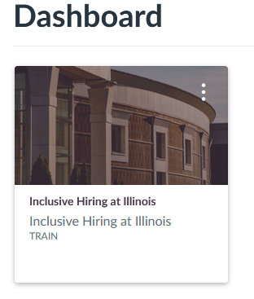
2. Click on the training link for the role you are fulfilling
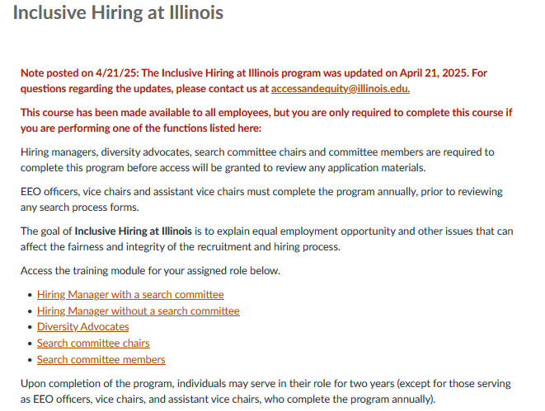

3. For a Search com member these modules are required:
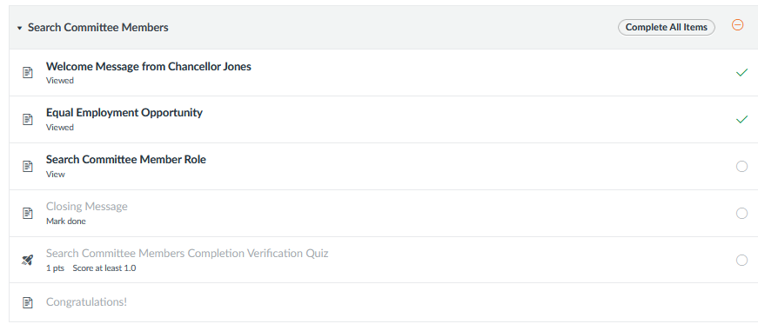
4. Click on the first video that does NOT have a green checkmark to start the training. When a module is completed, a green checkmark will appear on the right side (some modules are duplicated in other roles)
5. When done, click NEXT and you will be taken to the next module.
6. On your last module, watch the video, click the Mark as done button, then Next
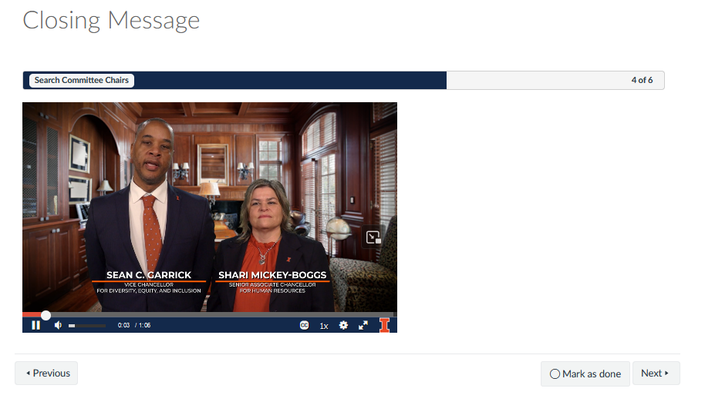
7. Click the Take the Quiz button
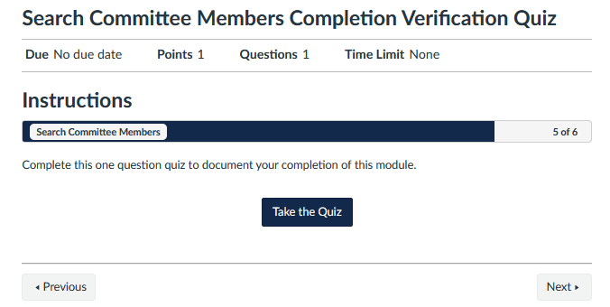

7. Answer true and click Submit Quiz.
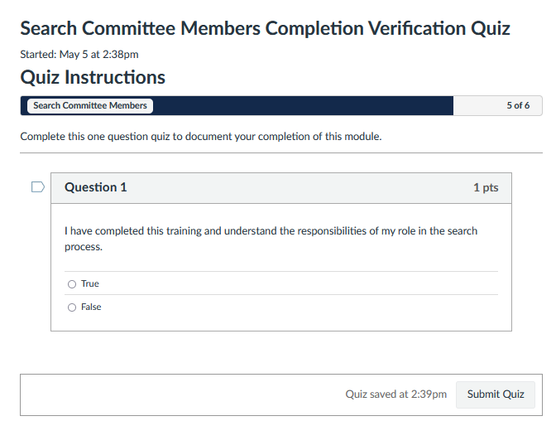
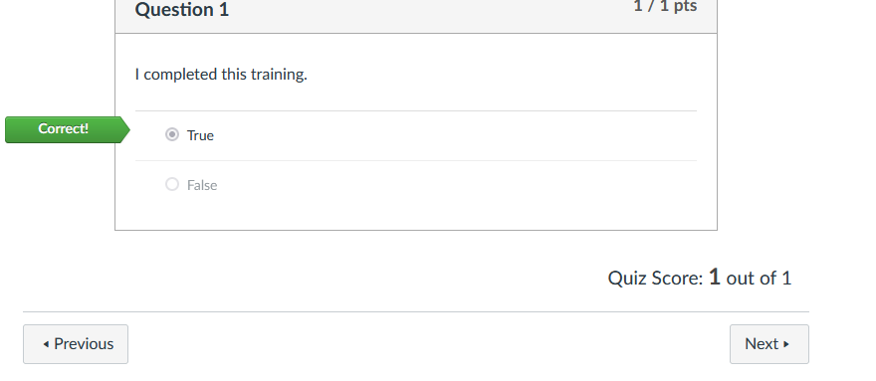
8. Click Next to complete the process

